Clean hygienically with steam: up to 99.999% of enveloped viruses are eliminated

Kärcher steam cleaners against the coronavirus

Press Contact
Moritz Dittmar
Press Officer
Alfred Kärcher SE & Co. KG
Alfred-Kärcher-Str. 28-40
71364 Winnenden, Germany
Tel. +49 (0) 71 95 14-3919
moritz.dittmar@de.kaercher.com
Winnenden, April 2020 – Kärcher arranged to have the effectiveness of its steam cleaners against viruses tested in an independent laboratory. The result: if used properly, the machines remove up to 99.999% of enveloped viruses*, such as the coronavirus or influenza, and 99.99% of common household bacteria** from hard surfaces. At the present time, disinfectants are to be reserved primarily for outpatient and inpatient care environments, whilst steam cleaners can make a valuable contribution to general hygiene – both in private households and in commercial and industrial use.
The laboratory test
Enveloped viruses such as the coronavirus SARS-CoV-2 can be neutralised with high temperatures. As viruses are not germs or living organisms, experts also talk about virus inactivation. In the laboratory a certified test virus (Modified-Vaccinia-Ankara-Virus), which is representative for enveloped viruses, was distributed on a hard surface. This area was then cleaned with the hand nozzle of a steam cleaner and the appropriate microfibre pad. It was demonstrated that a significant reduction of up to 99.999% of the viruses could be achieved at maximum steam pressure and with a cleaning duration of 30 seconds on one area.

Kärcher tested steam cleaners for domestic use as well as machines for professional use. Whether the steam is produced in a boiler or in a water heater, it doesn't affect the result in combating the virus; both technologies achieved a comparable result in the laboratory.

Important for the application
The hot water steam emerges at around 100 °C and is cooled down with increasing distance. In order to combat viruses effectively, the nozzle must therefore be guided directly over the surface. It is also important to ensure a sufficient cleaning duration and to choose a steaming duration of 30 seconds on one area with the maximum steam setting. The microfibre pads used must then be washed at a temperature of at least 60 °C in a standard wash programme (not Eco).

Positive side effects
Steam cleaners only need electricity and water and can be used for an almost unlimited time irrespective of the availability of disinfectants. As steam cleaners do not work with chemical cleaning agents, their application protects the users and their breathing, thus ensuring a comfortable room climate. Potentially allergic reactions from cleaning agent residues are also prevented, e.g. for children who play on the floor. Allergy sufferers benefit from the fact that the steam binds the dust and thus reduces the dispersal of allergens.
If used properly, Kärcher steam cleaners eliminate up to 99.999% of enveloped viruses*, such as the coronavirus or influenza, and 99.99% of common household bacteria** from hard surfaces.

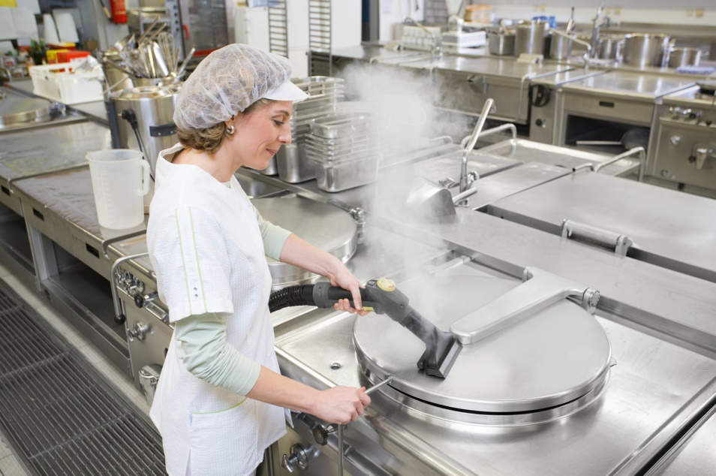
Steam cleaners and steam vacuum cleaners only need electricity and water and can be used for an almost unlimited time irrespective of the availability of disinfectants.

